**GitHub Link**

<https://github.com/SakthiSreeV/Html-and-Css>

**Screenshots:**

**Sign up page:**

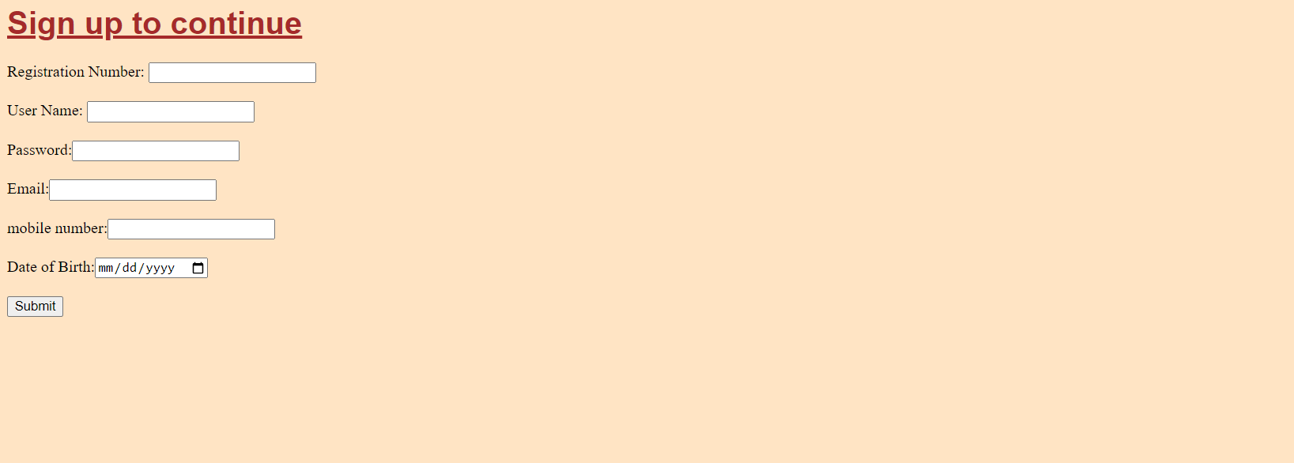

**Home page:**

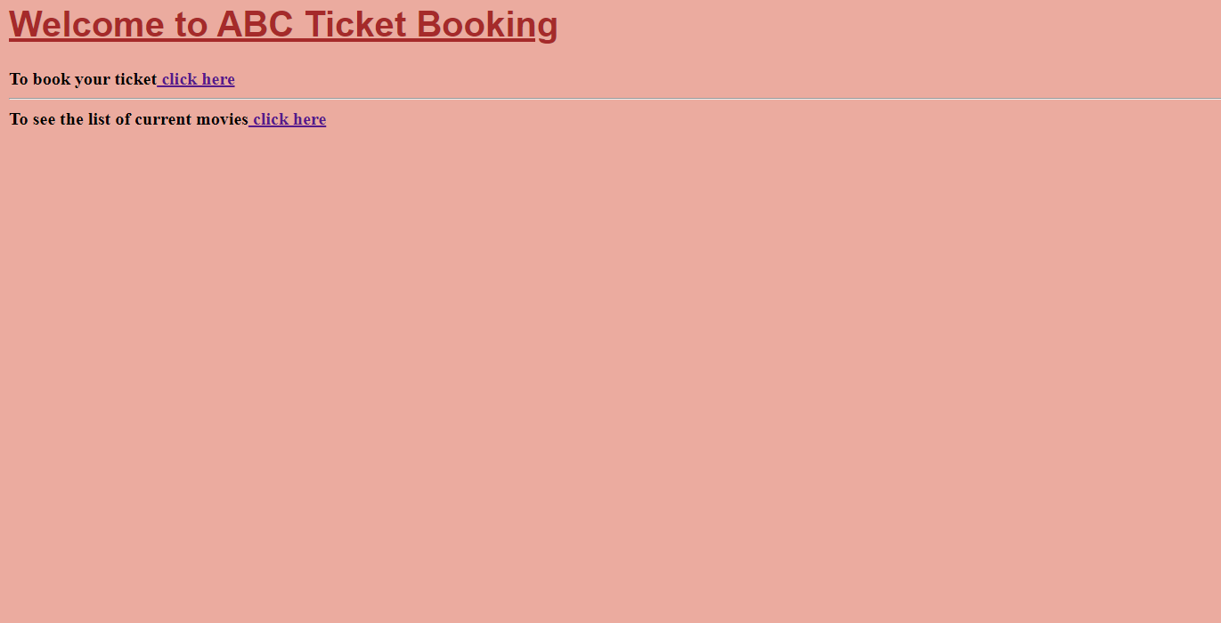

**Booking page:**

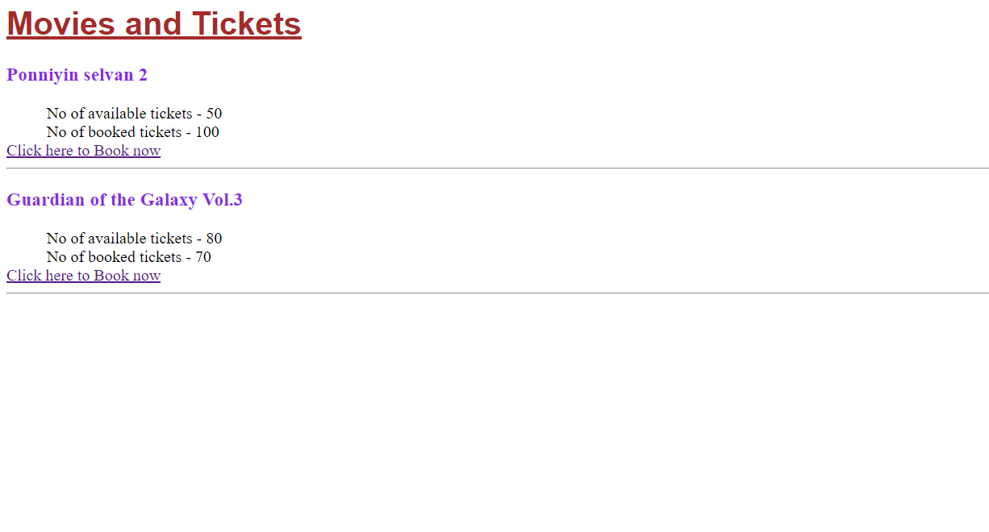

**Nowshowing Page:**

